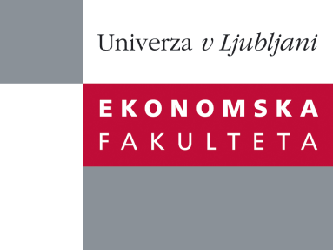

Raziskovalni center Ekonomske fakultete
organizira znanstveno - raziskovalni seminar,
ki bo v četrtek, 12. Januarja 2012, ob 12:00 uri
v P-109 na Ekonomski fakulteti v Ljubljani.

dr. Osman Gulseven

(Middle East Technical University)

bo predaval na temo:

"Indemnity Payments in Agricultural Insurance: Risk Exposure of EU States"

˝This study estimates the risk contributions of individual European countries regarding the indemnity payments in agricultural insurance. We model the total risk exposure as an insurance portfolio where each country is unique in terms of its risk characteristics. The data has been collected from the recent surveys conducted by the European Commission and the World Bank. Farm Accountancy Data Network is used as well. 22 countries out of 26 member states are included in the study. The results suggest that the Euro-Mediterranean countries are the major risk contributors followed by Germany and Netherlands. These countries not only have the highest expected loss but also a high volatility in indemnity payments. Nordic countries have the lowest indemnity payments and risk exposure.˝

Na brezplačni seminar se lahko prijavite v Službi za znanstveno raziskovalno delo, po telefonu (01) 58-92-490, ali po e-pošti na naslov research.seminars@ef.uni-lj.si, in sicer do srede 11.01.2012.

