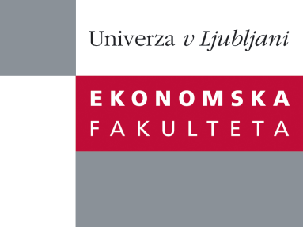

Raziskovalni center Ekonomske fakultete
organizira znanstveno - raziskovalni seminar,
ki bo v četrtek, 19. Januarja 2012, ob 12:00 uri
v P-109 na Ekonomski fakulteti v Ljubljani.

prof.dr. Mateja Drnovšek

(Univerza v Ljubljani, Ekonomska fakulteta)

bo predavala na temo:

˝Conceptualizing Academic Entrepreneurial Intentions: An Empirical Test˝

˝Policy makers are increasingly recognizing the catalytic role of academics’ spin-off companies in a national economy, which derives from their innovativeness that result in new value generation, and job creation. Although research on academics’ spin-off companies has been increasing, knowledge gaps exist as to the specific determinants and processes that characterize the emergence of academics’ entrepreneurial intentions that lead them to spin off companies. This research aims to fill this gap. Drawing from psychological and entrepreneurship research on intentionality, the authors propose a conceptual model of academics’ entrepreneurial intentions. They empirically test the model using structural equation modeling and a robust data set collected in two European academic settings to guide future research on this important topic.˝

Na brezplačni seminar se lahko prijavite v Službi za znanstveno raziskovalno delo, po telefonu (01) 58-92-490, ali po e-pošti na naslov research.seminars@ef.uni-lj.si, in sicer do srede 18.01.2012.

