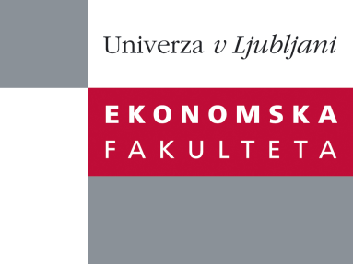

Raziskovalni center Ekonomske fakultete
organizira znanstveno - raziskovalni seminar,
ki bo v sredo, 11. Januarja 2012, ob 12:00 uri
v P-109 na Ekonomski fakulteti v Ljubljani.

Matija Lozej

(Banka Slovenije)

bo predaval na temo:

"Inefficiencies and Pigou Cycles"

"News about future productivity increase causes a recession in most neoclassical business cycle models, which is not in line with empirical evidence. This paper shows that this is not the case in a decentralised model that involves matching frictions and operates below the social optimum. The matching friction forces the agents to react early if they want to benefit from the productivity increase in the future. As entrepreneurs increase investment in new projects when the shock is announced, this pushes the economy towards a socially more efficient region and generates additional resources. These resources can be allocated to either consumption or to investment in equipment. The key element of the model is that investment in new projects complements investment in new equipment, which is why some of the additional resources are allocated to investment in equipment. This ensures a robust increase in output, employment, consumption, and investment before the news about future productivity becomes reality."

Na brezplačni seminar se lahko prijavite v Službi za znanstveno raziskovalno delo, po telefonu (01) 58-92-490, ali po e-pošti na naslov research.seminars@ef.uni-lj.si, in sicer do torka,10.01.2012
Vljudno vabljeni!

