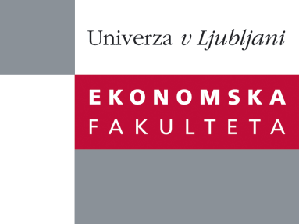

Raziskovalni center Ekonomske fakultete
organizira znanstveno - raziskovalni seminar,
ki bo v četrtek, 26. Januarja 2012, ob 12:00 uri
v P-109 na Ekonomski fakulteti v Ljubljani.

doc. dr. Simon Čadež

(Univerza v Ljubljani, Ekonomska fakulteta)

bo predstavil članek na temo:

˝Dual output in carbon intensive firms: implications for carbon strategy˝

˝A distinctive characteristic of carbon intensive firms is dual output. Products from these firms represent a positive output while carbon dioxide emissions are a negative output. The paper provides evidence that the strength of the dual output relationship depends on the nature of emissions (i.e. combustion vs process) in a particular firm or industry sector. This finding bears important implications for corporate carbon strategies in an environment of increased regulatory intervention with mutually exclusive goals to increase positive output and to reduce total CO2 emissions, such as: (1) emissions reduction strategy is not equivalent to improvement of carbon efficiency strategy, (2) carbon strategies are not universally applicable rather they are contingent upon overall business strategy and the nature of emissions in each firm.˝

Na brezplačni seminar se lahko prijavite v Službi za znanstveno raziskovalno delo, po telefonu (01) 58-92-490, ali po e-pošti na naslov research.seminars@ef.uni-lj.si, in sicer do srede 25.01.2012.

