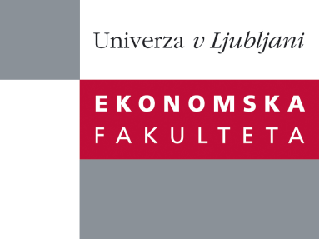

Raziskovalni center Ekonomske fakultete
organizira znanstveno - raziskovalni seminar,
ki bo v petek, 10. Februarja 2012 ob 12:00 uri
v P-109 na Ekonomski fakulteti v Ljubljani.

prof. dr. Boris Podobnik

((Univerza v Ljubljani, Ekonomska fakulteta)

bo predstavil članek:

"Asymmetric Lévy flight in financial ratios"

˝Because financial crises are characterized by dangerous rare events that occur more frequently than those predicted by models with finite variances, we investigate the underlying stochastic process generating these events. In the 1960s Mandelbrot and Fama proposed a symmetric Lévy probability distribution function (PDF) to describe the stochastic properties of commodity changes and price changes. We find that an asymmetric Lévy PDF, L, characterized by infinite variance, models several multiple credit ratios used in financial accounting to quantify a firm’s financial health, such as the Altman [Altman EI (1968) J Financ 23:589–609] Z score and the Zmijewski [Zmijewski ME (1984) J Accounting Res 22:59–82] score, and models changes of individual financial ratios, ΔXi. We thus find that Lévy PDFs describe both the static and dynamics of credit ratings. We find that for the majority of ratios, ΔXi scales with the Lévy parameter α ≈ 1, even though only a few of the individual ratios are characterized by a PDF with power-law tails Xi−1−α with infinite variance. We also find that α exhibits a striking stability over time. A key element in estimating credit losses is the distribution of credit rating changes, the functional form of which is unknown for alphabetical ratings. For continuous credit ratings, the Altman Z score, we find that P(ΔZ) follows a Lévy PDF with power-law exponent α ≈ 1, consistent with changes of individual financial ratios. Estimating the conditional P(ΔZ|Z) versus Z, we demonstrate how this continuous credit rating approach and its dynamics can be used to evaluate credit risk.˝

Na brezplačni seminar se lahko prijavite v Službi za znanstveno raziskovalno delo, po telefonu (01) 58-92-490, ali po e-pošti research.seminars@ef.uni-lj.si, in sicer do četrtka, 09.02.2012.

Vljudno vabljeni!

