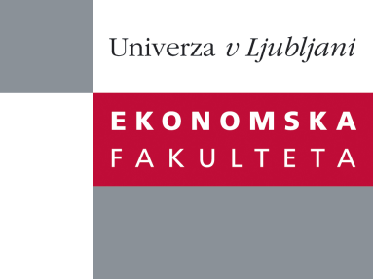

Raziskovalni center Ekonomske fakultete
organizira znanstveno - raziskovalni seminar,
ki bo v četrtek, 02. Februarja 2012, ob 12:00 uri
v P-109 na Ekonomski fakulteti v Ljubljani.

doc. dr. Marko Jakšič

(Univerza v Ljubljani, Ekonomska fakulteta)

bo predstavil članek na temo:

˝Inventory Management with Stochastic Supply Capacity˝

˝An important aspect of supply chain management is dealing with demand and supply uncertainty. The uncertainty of future supply can be reduced in several ways, of which the following will be discussed at the seminar: (1) a company is able to obtain advance capacity information about future supply/production capacity availability from its supplier, (2) the information about the state of the supply process (pipeline orders) is received prior to replenishment through advance supply information, and (3) the unfilled part of the supply is backordered at the supplier and thus can be replenished with a delay. In all of the above mentioned settings, a periodic-review inventory system under stochastic demand and stochastic limited supply is addressed. We formulate the problems as stochastic dynamic programming models, where the focus is in establishing the structural properties of the optimal policies. In addition, we reveal several managerial insights through numerical analysis.˝

Na brezplačni seminar se lahko prijavite v Službi za znanstveno raziskovalno delo, po telefonu (01) 58-92-490, ali po e-pošti na naslov research.seminars@ef.uni-lj.si, in sicer do srede, 01.02.2012.

