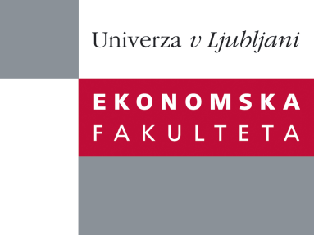

Raziskovalni center Ekonomske fakultete
organizira znanstveno - raziskovalni seminar,
ki bo v sredo, 15. Februarja 2012 ob 12:00 uri
v P-109 na Ekonomski fakulteti v Ljubljani.

prof. dr. Jože Damijan

((Univerza v Ljubljani, Ekonomska fakulteta)

bo predstavil članek:

"Import Churning and Export Performance of Multi-product Firms"

˝ This paper analyzes the impact of churning in the imported varieties of capital and intermediate inputs on firm export scope and productivity. Using detailed data on imports and exports at the firm–product level, we document substantial churning both in imports and exports for Slovenian firms in the period 1994-2008. An average firm changes about one quarter of imported and exported varieties every year, while gross churning in terms of added and dropped goods in trade is found to be almost three times higher. We find that a substantial proportion of this product churning is due to simultaneous imports and exports of firms in identical varieties within the same CN-8 product code (so called pass-on-trade). One quarter of all exported varieties and 40 per cent of all newly added exported varieties in the current year comprises varieties, which the same firm has imported previously. We find that the documented churning in imported varieties is far more important for firms’ productivity growth and increased export product scope than reduction in tariffs or declines in import prices. While similar in terms of the effects on the export scope, gross churning, however, is found to have a bigger impact on firm productivity improvements by a factor of more than 10 as compared to the net churning effects. Both adding and dropping of imported input varieties thus seem to be of utmost importance for firms aiming to optimize their input mix towards their most valuable inputs. These effects are further enhanced when excluding the simultaneous trade in identical varieties, suggesting that pass-on-trade has less favorable effects on firms’ long-run performance than regular trade.˝

Na brezplačni seminar se lahko prijavite v Službi za znanstveno raziskovalno delo, po telefonu (01) 58-92-490, ali po e-pošti research.seminars@ef.uni-lj.si, in sicer do torka, 14.02.2012.

Vljudno vabljeni!

