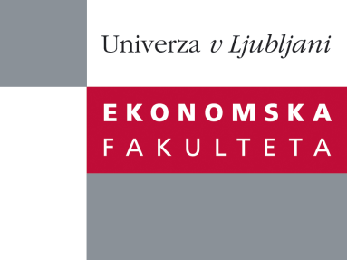

Raziskovalni center Ekonomske fakultete
organizira znanstveno - raziskovalni seminar,
ki bo v četrtek, 16. Februarja 2012 ob 12:00 uri
v P-109 na Ekonomski fakulteti v Ljubljani.

dr. Mateja Bodlaj

(Univerza v Ljubljani, Ekonomska fakulteta)

bo predstavila članek:

˝Do managers at two hierarchical levels differ in how they assess their company`s market orientation? ˝

˝The market orientation concept is central to marketing thinking and increasingly important in other fields such as strategic management. Meta-analyses confirm a positive relationship between a market orientation and business performance. However, most companies do not embrace the market orientation concept until they are driven to it by circumstances such as a sales decline, slow sales growth, changing buying patterns, increasing competition or poor results achieved from marketing expenditures. Although a market orientation is viewed as an appropriate business philosophy, companies find it difficult to implement it. Managers’ perceptions of their company’s market orientation effect managerial decision-making. The purpose of the presented empirical study was to examine the cultural and behavioural adoption of a market orientation as perceived by two groups of managers: general managers and marketing managers. With regard to market-oriented behaviours, a distinction is made between a responsive and a proactive market orientation. Based on a single-informant approach, comparisons between both groups of managers are made by testing invariant latent mean structures. An analysis of 363 Slovenian companies reveals that the general managers perceived all components of a market orientation significantly better than the marketing managers˝.

Na brezplačni seminar se lahko prijavite v Službi za znanstveno raziskovalno delo, po telefonu (01) 58-92-490, ali po e-pošti na naslov research.seminars@ef.uni-lj.si, in sicer do srede, 15.02.2012.
Vljudno vabljeni!

