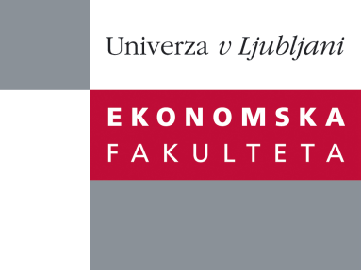

Raziskovalni center Ekonomske fakultete
organizira znanstveno - raziskovalni seminar,
ki bo v sredo, 29. Februarja 2012 ob 12:00 uri
v P-109 na Ekonomski fakulteti v Ljubljani.

Predstavljen bo članek:

"Product display orientation- horizontal or vertical?
The role of product characteristics"

avtorji: dr. Mitja Pirc (skupaj z M. Bertini, LBS in A. Valenzuela, UPF)

˝A large literature demonstrates that contexts and frames influence consumer decisions.We propose that product display orientation, horizontal or vertical, influences decisions through two mechanisms: fluency, i.e. psychological cost of the decision making process, and congruence, i.e. feeling right with the choice and impacting the perceived utility with the decision made. The effect differs for hedonic and utilitarian products. When decision involves hedonic goods, then consumers process more affectively and any orientation gives fluency, which in turn increases the likelihood of decision. On the other hand, when decision is about utilitarian goods, then consumers process more analytically, congruence matters and the right kind of orientation is proposed to be the vertical one. We find support for the effect of orientation in a field experiment accross 15 grocery products from different categories. The support for the underlying mechanisms of fluency and congruence is found in a controlled experiment including 6 grocery products from different categories. Our findings add to the literature on consumer choice and specifically on the literature on visual information processing. Implications for retailers and other sectors are discussed.˝

Na brezplačni seminar se lahko prijavite v Službi za znanstveno raziskovalno delo, po telefonu (01) 58-92-490, ali po e-pošti research.seminars@ef.uni-lj.si, in sicer do torka, 28.02.2012.

Vljudno vabljeni!

