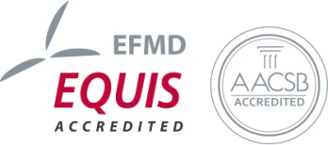
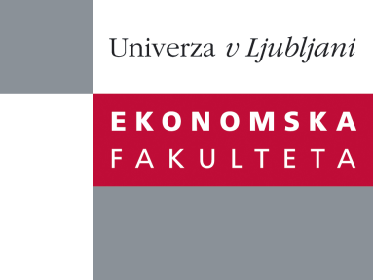

Raziskovalni center Ekonomske fakultete
organizira znanstveno - raziskovalni seminar,
ki bo v sredo, 07. Marca 2012 ob 12:00 uri
v P-109 na Ekonomski fakulteti v Ljubljani.

Predstavljen bo članek:

"Revenue and Profit Implications of Industrial Service Strategies"

avtor: prof. dr. Andreas Eggert (Lehrstuhl für Betriebswirtschaftslehre, insbes. Marketing, Fakultät für Wirtschaftswissenschaften)

(Profesor je v svetovnem merilu vrhunski strokovnjak na področju znanstvenih raziskav, ki se osredotočajo na vlogo in pomenu vrednosti na medorganizacijskih trgih, med drugim je objavil članke v top trženjskih publikacijah in prejel številne nagrade, nedavno nagrado za najboljše raziskovalni prispevek na konferenci združenja American Marketing Association)

˝Manufacturing companies increasingly seek service-led growth to secure their existing positions and continue to grow. Using longitudinal data from 513 German mechanical engineering companies and latent growth curve modeling, this study offers a fine-grained view on the financial performance implications of industrial service strategies. By disentangling their revenue and profit implications, we find that industrial services increase both the initial baseline level and the growth of manufacturing firms’ revenue streams. In contrast, they reduce the initial baseline level but improve the growth of manufacturers’ profits. Our research further reveals the key mediating role of services supporting the clients’ actions (SSCs). SSCs directly affect revenue and profit streams whereas services supporting the supplier’s product (SSPs) show only indirect effects on both financial performance measures. A moderator analysis identifies two important organizational contingencies that facilitate service business success. Only those companies with decentralized decision-making processes and a high share of loyal customers can expect favorable financial results from industrial service strategies. In sum, our research provides significant insights and managerial guidance for turning service strategies into financial success. ˝

Na brezplačni seminar se lahko prijavite po telefonu (01) 58-92-490, po e-pošti research.seminars@ef.uni-lj.si do torka, 06.03.2012.
Vljudno vabljeni!

