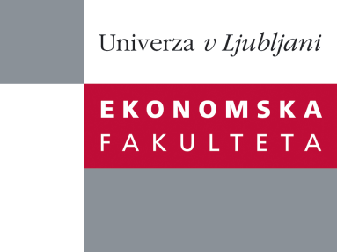

Raziskovalni center Ekonomske fakultete
organizira znanstveno - raziskovalni seminar,
ki bo v četrtek, 23. Februarja 2012, ob 12:00 uri
v P-109 na Ekonomski fakulteti v Ljubljani.

Predstavljen bo članek:

˝Don`t come around here no more: Knowledge hiding, perceived motivational climate, and creativity˝

avtorji: Miha Škerlavaj, Faculty of Economics University of Ljubljana, Slovenia; Matej Černe, The Centre of Excellence for Biosensors, Instrumentation, and Process Control COBIK, Slovenia; Christina Nerstad, BI Norwegian Business School, Norway in Anders Dysvik, BI Norwegian Business School, Norway

˝In two studies, using both field and experimental data, we propose and empirically test a multi-level model of cross-level interactions between knowledge hiding, perceived motivational climate, and employee creativity. A field study of 240 employees nested within 34 groups showed a negative relationship between knowledge hiding and creativity. Furthermore, moderation analysis indicated that perceived mastery climate positively moderates the relationship between knowledge hiding and creativity, whereas perceived performance climate negatively moderates this relationship. Study 2 replicated these findings in an experimental study of 86 undergraduate students, controlling for the influence of task. Implications for practice and future research are discussed.˝

Na brezplačni seminar se lahko prijavite v Službi za znanstveno raziskovalno delo, po telefonu (01) 58-92-490, ali po e-pošti na naslov research.seminars@ef.uni-lj.si, in sicer do srede, 22.02.2012.
Vljudno vabljeni!

