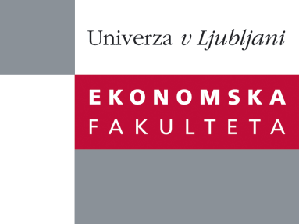

Raziskovalni center Ekonomske fakultete
organizira znanstveno - raziskovalni seminar,
ki bo v sredo, 29. Februarja 2012, ob 14:00 uri
v P-109 na Ekonomski fakulteti v Ljubljani.

Predstavljen bo članek:

˝How brands help growing out of a recession˝
avtor: prof. Leslie de Chernatony

(Università della Svizzera italiana, Lugano, Switzerland in Aston Business School, Birmingham, UK)

˝Some markets are gradually starting to show signs (albeit weak) of recovery after one of the most severe recessions in numerous countries, while in others there are questions about when growth will return. A not infrequent strategy followed was to cut back on brand investment in the hope of being able to ride out the economic storm. Yet this “batten down” strategy overlooks the literature about how brand management can help organizations grow out of a recession. This presentation will draw on the literature to address what is known about successful brand management during and shortly after recessions.˝

Na brezplačni seminar se lahko prijavite v Službi za znanstveno raziskovalno delo, po telefonu (01) 58-92-490, ali po e-pošti na naslov research.seminars@ef.uni-lj.si, in sicer do torka, 28.02.2012.

Vljudno vabljeni!

