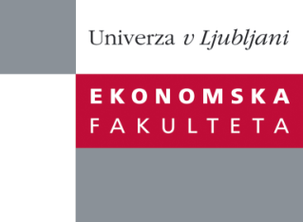

Raziskovalni center Ekonomske fakultete
organizira znanstveno - raziskovalni seminar,
ki bo v četrtek, 28.03.2013, ob 12:00 uri
v P-109 na Ekonomski fakulteti v Ljubljani.

Predstavljen bo članek:

“The study of perceived adverse effects of digital piracy and involvement: insights from adult computer users”

Avtorica: doc. dr. Mateja Kos Koklič, Ekonomska fakulteta, Univerza v Ljubljani (skupaj s: prof. dr. Irena Vida, doc. dr. Domen Bajde, asist. dr. Barbara Culiberg)

In this study, we focus on two sets of expected negative consequences of engaging in digital piracy among the seldom studied adult computer users rather than student population. We delve into the role of perceived risk and moral intensity as drivers of consumers’ attitudes and behavioural intentions, and explore the rarely examined moderating effect of issue involvement on the relationship between the attitude and intention to pirate. The dominant attitude–behaviour theory is extended with an ethical decision-making theoretical perspective. The hypotheses are tested via mail survey data from a random sample of adult consumers using structural equations modelling. The results of this cross-sectional study show unfailing support for the relationships proposed in our model. Our findings suggest that, in addition to perceived risk, moral intensity (i.e. the expected consequences for others), has a particularly strong total effect on the intention to pirate, and that consumer involvement in illegally downloading files is a salient factor moderating the relationship between attitudes and behavioural intentions. Based on this pattern of results, we offer theoretical and practical implications.

Na brezplačni seminar se lahko prijavite v Službi za znanstveno raziskovalno delo, po telefonu (01) 58-92-490 ali po e-pošti research.seminars@ef.uni-lj.si, do srede, 27.03.2013.

Vljudno vabljeni!

