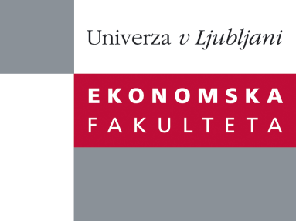

Raziskovalni center Ekonomske fakultete
organizira znanstveno - raziskovalni seminar,
ki bo v sredo, 21. Februarja 2012 ob 12:00 uri
v P-109 na Ekonomski fakulteti v Ljubljani.

Predstavljen bo članek:

"Evolution of Private Returns to Tertiary Education during Transition: Evidence from Slovenia "

avtorji: Tjaša Bartolj (skupaj z izr. prof. dr. Aleš Ahčan, doc. dr. Aljoša Feldin in doc. dr. Sašo Polanec)

˝This paper estimates private rates of return to different levels and fields of tertiary education in Slovenia during the period 1994-2008. We find that during transition annual returns follow an inverse U-shaped pattern. In the period 1994-2001, the returns to all levels, except the PhD, rose in spite of the increasing shares of workers with 4-year UG degrees or higher. This was followed by a drop in the rates of return in the period 2001-2008. In addition, we observe considerable heterogeneity in rates of return between genders, different levels, and fields of study, with especially large returns in the beginning of the analyzed period to the fields that were neglected during socialism. The differences in the returns between levels of tertiary education are an argument against Card's (1999) idea of proportional effect of each additional year of education on earnings. We also confirm the existence of positive ability bias and find that in more homogeneous groups males usually have higher rates of return than females.˝

Na brezplačni seminar se lahko prijavite v Službi za znanstveno raziskovalno delo, po telefonu (01) 58-92-490, ali po e-pošti research.seminars@ef.uni-lj.si, in sicer do torka, 20.02.2012.

Vljudno vabljeni!

