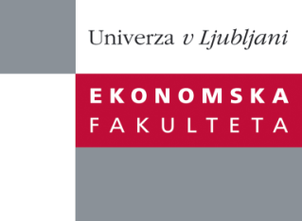

Raziskovalni center Ekonomske fakultete
organizira znanstveno - raziskovalni seminar,
ki bo v sredo, 16. Januar 2013, ob 12:00 uri
v P-109 na Ekonomski fakulteti v Ljubljani.

Predstavljen bo članek:

“ Deductive Data Imputation - An Exact Analytical Grossing-Up Algorithm for Tax-Benefit Models "

Avtor: prof. dr. Mitja Čok (soavtorji: prof. dr. Tomaž Turk in prof. dr. Miroslav Verbič, Ekonomska fakulteta, Univerza v Ljubljani)

˝ Data imputation techniques rely on deterministic and stochastic approaches, mostly under the assumption that the variable in question is in some way related to other variables under investigation. In this paper, we are employing a deductive data imputation approach to develop a non-trivial grossing-up algorithm which allows for gross income calculation on the basis of tax rules and observed (measured) variables in the sample. Namely, the deductive approach allows for the reproduction of a missing variable by applying a set of rules which are known to refer to the variable in question and to other variables in the dataset during the data generation process. If this set of rules is consistent and comprehensive, the researcher can develop a formal analytical algorithm with respect to the rules and variables in the dataset which allows for the complete and exact restoration of the missing variable. The proposed algorithm involves a combination of partial analytical solutions and a trial-and-error approach. Its validity was proven by a set of tax rules combinations at different levels of income which are used in contemporary tax systems. The algorithm is generally applicable for data imputation on datasets derived from contemporary tax systems around the world ˝

Na brezplačni seminar se lahko prijavite v Službi za znanstveno raziskovalno delo, po telefonu (01) 58-92-490 ali po e-pošti research.seminars@ef.uni-lj.si, do torka, 15.01.2013.
Vljudno vabljeni!

