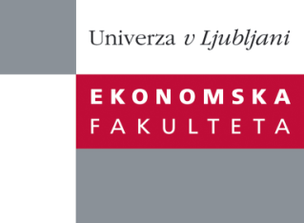

Raziskovalni center Ekonomske fakultete
organizira znanstveno - raziskovalni seminar,
ki bo v sredo, 03. Aprila 2013, ob 16:00 uri
v P-125 na Ekonomski fakulteti v Ljubljani.

Predstavljen bo članek:

“Greening the Organisational Field of Government ICT: a problem-driven, mechanism-based approach"

Avtor: prof. dr. Raymond A Hackney, Brunel University, Business School, London, Velika Britanija

˝ In the United Kingdom, public sector information and communication technologies (ICT) are responsible for between 35-38% of total ICT-related Greenhouse Gas (GHG) emissions. A problem-driven approach to the analysis of the institutional mechanisms will be presented that lead to the direct, enabling, and systematic effects of Green ICT in public sector organizations. Using mechanism-based explanatory model as a sensitizing device, the field study findings were then employed to develop mechanism-based explanations of the institutionalization of the UK government’s Green ICT strategy, which underpins the government’s efforts to reduce its GHG emissions. There are obvious lessons here for the public sector globally, while practical insights into how government-led Green ICT-based initiatives can institute wider societal and organizational change are also presented. One significant finding is that contrary to the ‘Iron Law’ of climate policy, the cost savings associated with the introduction of Green ICT provide more effective incentives for governments and public sector organisations than environmental concerns alone.˝

Na brezplačni seminar se lahko prijavite v Službi za znanstveno raziskovalno delo, po telefonu (01) 58-92-490 ali po e-pošti research.seminars@ef.uni-lj.si, do torka, 02.04.2013.

Vljudno vabljeni!

