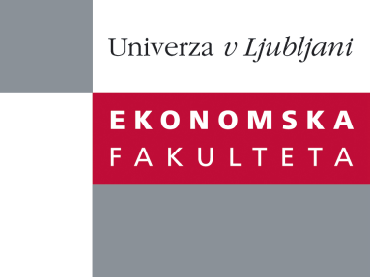

Raziskovalni center Ekonomske fakultete
organizira znanstveno - raziskovalni seminar,
ki bo v četrtek, 05. Aprila 2012 ob 12:00 uri
v P-109 na Ekonomski fakulteti v Ljubljani.

Predstavljen bo članek:

"Minimum Wage And Informal Economy"

avtorji: doc. dr. Aljoša Feldin (skupaj z doc. dr. Sašo Polanec, Univerza v Ljubljani, Ekonomska fakulteta)

˝We present a simple partial equilibrium model of a monopolistically competitive firm hiring labor on a competitive market and facing several public policy instruments. Corporate and value added taxes along with payroll expenses drive a firm towards informal economy, while government's efforts in identifying these deviations together with punitive lump sum fines pull them back. We show that under circumstances in which firm optimally underreports its sales and wages paid the binding minimum wage rate instruments not only less wage underreporting but necessarily also higher reported sales.˝

Na brezplačni seminar se lahko prijavite v Službi za znanstveno raziskovalno delo, po telefonu (01) 58-92-490, ali po e-pošti research.seminars@ef.uni-lj.si, in sicer do, srede, 04.04.2012.

Vljudno vabljeni!

