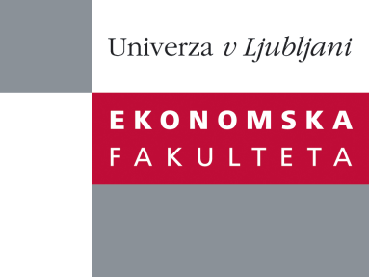

Raziskovalni center Ekonomske fakultete
organizira znanstveno - raziskovalni seminar,
ki bo v sreda, 12. oktobra 2011, ob 12:00 uri
v P-109 na Ekonomski fakulteti v Ljubljani.

Prof. dr. Aljoša Valentinčič

(Univerza v Ljubljani, Ekonomska fakulteta)

bo predstavil članek:

“Write-Offs and Profitability in Private Firms – Disentangling the Impact of Tax-Minimization Incentives”

"Observing firms choosing accounting policies that generate tax savings is complex due to: (i) tax and nontax costs of reporting lower net income; (ii) accounting policies that result in lower reported income, do not generate tax savings, but generate nontax benefits; (iii) multiple incentives of financial statement preparers; and (iv) econometric issues. We observe a large sample of 20,505 private firms, which are characterized by relatively few agency problems between owners and managers, writing off assets in two separate regimes, one that generates tax savings and the other that does not. Firms significantly decrease, but continue to use, asset write-offs after the exogenous adverse change in tax treatment of these write-offs. The tax shift does not affect any other economic incentive to use accounting discretion to achieve a desired financial reporting outcome. This allows us to disentangle the tax-minimization incentive from other (un)observable incentives including debt contracting, dividends and employee relations that cause the observed anomalous positive relation between write-offs and profitability. We thus show that: (i) obtaining tax savings is an important consideration and that (ii) nontax costs and benefits are likely important for private firms as well."
Na brezplačni seminar se lahko prijavite v pisarni RCEF, po telefonu (01) 58-92-490, ali po e-pošti na naslov sodelavec.rcef@ef.uni-lj.si do torka,11.10.2011.
Vljudno vabljeni!

