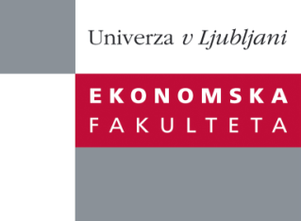

Raziskovalni center Ekonomske fakultete
organizira znanstveno - raziskovalni seminar,
ki bo v sredo, 20. Marca 2013, ob 12:00 uri
v P-109 na Ekonomski fakulteti v Ljubljani.

Predstavljen bo članek:

“Structural FECM: Cointegration in large-scale structural FAVAR
models"

Avtor: prof. dr. Igor Masten, Ekonomska fakulteta, Univerza v Ljubljani (skupaj z: Anindya Banerjee, Banque de France and Department of Economics, University of Birmingham; Massimiliano Marcellino, European University Institute, Bocconi University and CEPR)

˝ In this paper we discuss the implications of dynamic factor models for the analysis of vector error-correction models. Starting from the dynamic factor model for non-stationary data we derive the factor-augmented error correction model (FECM) and, by generalizing the Granger representation theorem to nonstationary dynamic panel, its moving-average representation. The latter is used for discussion identi_cation schemes of structural shocks. Besides discussing contemporaneous restrictions, we show that the structural FECM o_ers a generalization of classical identi_cation schemes based on long-run restrictions to the case of large panels. The importance of the error-correction mechanism for impulse response analysis is analysed by means of both empirical examples and simulation experiments. Our results show that the bias in estimated impulse responses in a FAVAR model is positively related to the strength of the error-correction mechanism and the cross-section dimension of the panel. We observe empirically in large panel of US data that these features have a signi_cant e_ect on responses of several variables to the identi_ed real stochastic trend.˝

Na brezplačni seminar se lahko prijavite v Službi za znanstveno raziskovalno delo, po telefonu (01) 58-92-490 ali po e-pošti research.seminars@ef.uni-lj.si, do torka, 19.03.2013.
Vljudno vabljeni!

