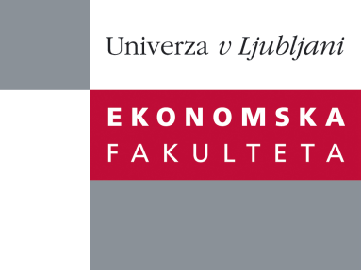

Raziskovalni center Ekonomske fakultete
organizira znanstveno - raziskovalni seminar,
ki bo v četrtek, 08. Marca 2012, ob 12:00 uri
v P-109 na Ekonomski fakulteti v Ljubljani.

Predstavljen bo članek:

˝A consumer-based model of authenticity: An oxymoron or the foundation of cultural heritage marketing? ˝

avtorji: doc. dr. Tomaž Kolar, University of Ljubljana, Faculty of Economics (skupaj z prof. dr. Vesna Žabkar, University of Ljubljana, Faculty of Economics)
˝This study examines the relevance and conceptualizations of the authenticity concept in cultural tourism from the managerial standpoint. We propose a consumer-based model in which authenticity is a key mediating construct between cultural motivation and loyalty. The model is empirically examined by means of a survey conducted on 25 Romanesque heritage sites in four European countries. A confirmatory factor analysis and structural equation modeling were performed using LISREL 8.72. The results indicate that cultural motivation is an important antecedent of both object-based and existential authenticity, which in turn influence tourist loyalty. Theoretical, managerial and marketing implications of authenticity are discussed, showing that the consumer-based perspective can transcend some 'irreconcilable tensions' related to this concept.˝
Predstavitev bo vključevala vsebino članka nagrajenega z 2. nagrado raziskovalcem za najboljši objavljeni znanstveni članek v letu 2010.

Na brezplačni seminar se lahko prijavite v Službi za znanstveno raziskovalno delo, po telefonu (01) 58-92-490, ali po e-pošti research.seminars@ef.uni-lj.si, in sicer do srede, 07.03.2012.

Vljudno vabljeni!

