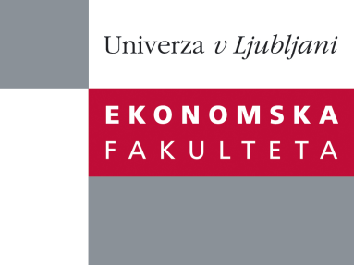

Raziskovalni center Ekonomske fakultete
organizira znanstveno - raziskovalni seminar,
ki bo v sredo, 11. Aprila 2012 ob 12:00 uri
v P-109 na Ekonomski fakulteti v Ljubljani.

Predstavljen bo članek:

"Estimation of the Efficiency Wage Effect Using a Model of Efficiency Wages, Unemployment Benefits and Union-firm Wage Bargaining"

avtorji: Vesna Stavrevska, University of Antwerp, Belgium (skupaj z W. Meeusen)

˝ We develop a method to test the importance of efficiency wages mechanisms and union-firm wage bargaining in the wage formation process, based on the generic model of efficiency wages by Meeusen et al. (2011). This empirical model is applied on data for Belgium, Austria and the USA. We use a wide variety of specifications to empirically analyse the factors of wage formation. Across countries and across specifications the estimated combined impact of efficiency wages and union-firm bargaining systematically dominates the impact of the competitive market forces in a statistically significant way. ˝

Na brezplačni seminar se lahko prijavite v Službi za znanstveno raziskovalno delo, po telefonu (01) 58-92-490, ali po e-pošti research.seminars@ef.uni-lj.si, in sicer do, torka, 10.04.2012.

Vljudno vabljeni!

