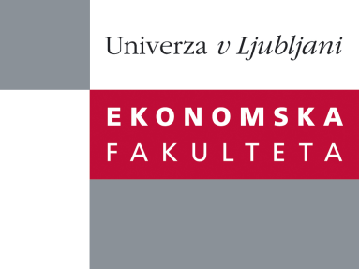

Raziskovalni center Ekonomske fakultete
organizira znanstveno - raziskovalni seminar,
ki bo v torek, 05. julija 2011, ob 12:00 uri
v Sejni sobi CISEF-a na Ekonomski fakulteti v Ljubljani.

Prof. dr. Ali Dastmalchian

(Gustavson School of Business, UVic, Canada)

bo predstavil članek:

“Organizational Change and Occupational Groups: A Longitudinal Study”

This presentation reports on a study examining the differential impact of a major organizational change in two units of an organizational in steel industry on employees in production and craft occupational groups. Downsizing pressures and the existing occupational distribution of knowledge, skills and abilities led to the creation of multi-skilled teams rather than teams of multi-skilled workers. As a result of these changes, production workers report work intensification and craft workers report skills underutilisation and reduced commitment to the organization. The results demonstrate the importance of understanding the differential impact of organizational change and the limits imposed on workplace transformation by the occupational structure of knowledge, skills and abilities in the traditional labour process. Findings from two other parallel longitudinal studies on major organizational change in Canadian organizations in healthcare will also be reported. These two other papers link major organizational change to the emergence of “distributed” or ”collective” leadership as well as the need to align organizational logic of change to trust as a moral and ethical imperative.

O predavatelju: Dr. Ali Dastmalchian is Dean and Professor of Organizational Analysis, Gustavson School of Business, University of Victoria, B.C., Canada. Prior to this he has been Dean, Director of Graduate programs and Department Head at three other Canadian Universities. He has also taught and has done research at University of Alberta, Athabasca University in Canada, Cardiff Business School, and Durham Business School in the U.K, National Sun Yat-Sen University in Taiwan, Deakin University Business School in Australia, Copenhagen Business School in Denmark, Rouen Business School in France, and Bogazici University’s Business School in Turkey.

Na brezplačni seminar se lahko prijavite v pisarni RCEF po telefonu (01) 58-92-490, ali po e-pošti na naslov sodelavec.rcef@ef.uni-lj.si do ponedeljka, 04.07.2011.
Vljudno vabljeni!

