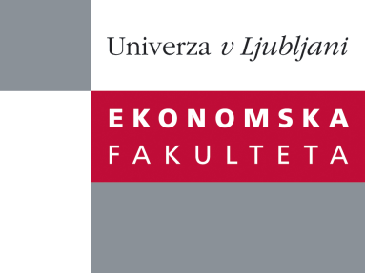

Raziskovalni center Ekonomske fakultete
organizira znanstveno - raziskovalni seminar,
ki bo v sredo, 21. Decembra 2011, ob 12:00 uri
v P-109 na Ekonomski fakulteti v Ljubljani.

Matjaž Volk, dipl. ekon.

(Banka Slovenije)

bo predaval na temo:

"Firms' PDs with Applications to Credit Rating Classification and Credit Standards for New Borrowers"

Credit risk is the main risk in the banking sector and is as such one of a key issues for financial stability. In this paper we estimate various PD models and use them in two applications. Models include both, firm-specific characteristics and macroeconomic effects. By linking firms' PDs with all their relations to banks we find that internal credit ratings do not allways represent the same level of borrowers' riskiness as estimated default probabilities and are less related to the business cycle than PDs. We also find an evidence of flight to quality in granting credits to new borrowers.

Na brezplačni seminar se lahko prijavite v Službi za znanstveno raziskovalno delo, po telefonu (01) 58-92-490, ali po e-pošti na naslov research.seminars@ef.uni-lj.si, in sicer do torka, 20.12.2011.
Vljudno vabljeni!

