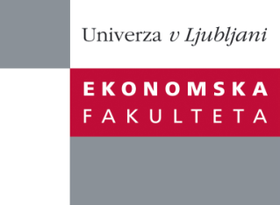

Raziskovalni center Ekonomske fakultete
organizira znanstveno - raziskovalni seminar,
ki bo v sredo, 27. Marca 2013, ob 12:00 uri
v P-109 na Ekonomski fakulteti v Ljubljani.

Predstavljen bo članek:

“Trade in Tasks and the Organization of Firms"

Avtor: dr. Alexander Tarasov, University of Munich (skupaj s prof. dr. Dalia Marin, University of Munich)

˝ We incorporate trade in tasks a là Grossman and Rossi-Hansberg (2008) into the international trade theory of firm organization of Marin and Verdier (2012) to examine how offshoring affects the way firms organize. We test the predictions of the model based on firm level data of 660 Austrian and German multinational firms with 2200 subsidiaries in Eastern Europe and the former Soviet Union and we show that the data are consistent with the theory. We find that offshoring of production labour leads firms to reorganize to a more decentralized hierarchy improving competitiveness of offshoring firms. We also show that offshoring of skilled managers relaxes the war for talent constraint in the North but toughens competition and thus has an ambiguous impact on the relative wage of skilled managers in the offshoring country. We show, however, that when the North is not too open to foreign competition offshoring of managers unambiguously lowers relative CEO wages and leads to more centralized firms in the North.˝

Na brezplačni seminar se lahko prijavite v Službi za znanstveno raziskovalno delo, po telefonu (01) 58-92-490 ali po e-pošti research.seminars@ef.uni-lj.si, do torka, 26.03.2013.

Vljudno vabljeni!

