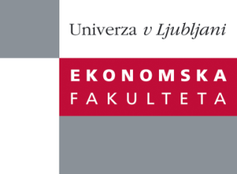

Raziskovalni center Ekonomske fakultete
organizira znanstveno - raziskovalni seminar,
ki bo v petek, 17. Maja 2013, ob 14:00 uri
v P-125 na Ekonomski fakulteti v Ljubljani.

Predstavljen bo članek:

“Revisiting herding behaviour: likelihood evidence"

Avtor: prof. dr. Efthymios G. Tsionas, Department of Economics, Athens University of Economics and Business, Athens, Greece

˝ Abstract We examine herding behavior in the US stock market, employing 30 blue chip companies of the Dow Jones Industrial Average Index, through 2001-2011. We propose a novel multivariate stochastic volatility methodology extended to allow for common factors that detect and measure the contribution of herding conditional on stylized-fact features of returns. We document the existence of herding during the recent global financial crisis and its aftermath. Our results have important policy implications and highlight the significant changes encountered by the global financial system as well as the increased systemic risk market participants are exposed to.˝

Na brezplačni seminar se lahko prijavite v Službi za znanstveno raziskovalno delo, po telefonu (01) 58-92-490 ali po e-pošti research.seminars@ef.uni-lj.si, do četrtka, 16.05.2013.

Vljudno vabljeni!

