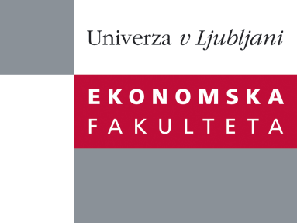

Raziskovalni center Ekonomske fakultete
organizira znanstveno - raziskovalni seminar,
ki bo v sredo, 18. Aprila 2012 ob 12:00 uri
v P-109 na Ekonomski fakulteti v Ljubljani.

Predstavljen bo članek:

"All You Need Is Trade: On the In(ter)dependence of Trade and Asset Holdings in Gravity Equations˝

avtorji: prof. dr. Joern Kleinert, University of Graz (skupaj z dr. Katja Neugebaure, Institute for Applied Economic Research (IAW) Tuebingen)

˝This paper looks at the interrelationship between trade in goods and asset holdings, as brought forward by some contributions to the empirical literature in international economics. These contributions argue that single-equation gravity models suffer from an endogeneity bias, culminating in a request for the estimation of systems of gravity equations. Yet, the theoretical basis for such an interrelationship is weak. In this paper we present baseline models of international trade in goods and bank asset holdings, which yield gravity equations that can be tested empirically. We then use these models to test three different explanations for the interrelationship between trade in goods and asset holdings that have been brought forward by the literature: (i) consumption hedging, (ii) sovereign risk, (iii) information spillovers. Our results indicate that none of these channels can explain the interrelationship. We therefore conclude that single-equation gravity models, as opposed to systems of gravity equations, are justified: All you need is trade! ˝

Na brezplačni seminar se lahko prijavite v Službi za znanstveno raziskovalno delo, po telefonu (01) 58-92-490, ali po e-pošti research.seminars@ef.uni-lj.si, in sicer do, torka, 17.04.2012.
Vljudno vabljeni!

