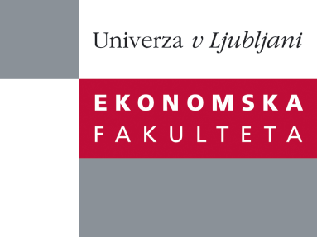

Raziskovalni center Ekonomske fakultete
organizira znanstveno - raziskovalni seminar,
ki bo v četrtek, 15. Marca 2012, ob 13:00 uri
v P-109 na Ekonomski fakulteti v Ljubljani.

Predstavljen bo članek:

˝ Exploring the landscape of HRM-firm performance debate domains: A co-citation analysis ˝

avtorji: doc. dr. Robert Kaše, University of Ljubljana, Faculty of Economics (skupaj z Saša Batistič, Doctoral Student, Henley Business School, University of Reading, United Kingdom)

HRM-performance debate has been one of the most popular debates within the HRM as a field of research for the past twenty years and simultaneously served as the field’s beacon for the general management audience (e.g., Huselid, 1995). Along with the maturity of the HRM-performance debate in the last decade came also numerous reflections and exchanges among scholars within the field about the development and future potential of the debate (e.g., Boselie, Dietz, & Boon, 2005; Combs, Yongmei, Hall, & Ketchen, 2006; Martín-Alcázar, Romero-Fernández, & Sánchez-Gardey, 2008). However, there has not been much attention paid to a systematic analysis of the knowledge domains that have informed the debate. In this paper, we address this gap and perform a cocitation analysis featuring the island procedure (De Nooy, Mrvar, & Batagelj, 2011) of more than 20,000 scholarly contributions from ISI Web of Knowledge that researchers studying HRM-performance co-cited between 1985 and 2010. Based on this extensive analysis we comment on the extant development of the debate and its future prospects.

Na brezplačni seminar se lahko prijavite v Službi za znanstveno raziskovalno delo, po telefonu (01) 58-92-490, ali po e-pošti research.seminars@ef.uni-lj.si, in sicer do srede, 14.03.2012.

Vljudno vabljeni!

