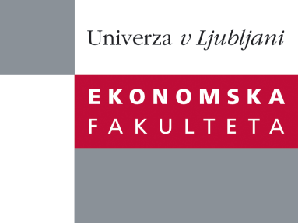

Raziskovalni center Ekonomske fakultete
organizira znanstveno - raziskovalni seminar,
ki bo v sredo, 04. Januarja 2012, ob 12:00 uri
v P-109 na Ekonomski fakulteti v Ljubljani.

prof. dr. Carole Bernard

(University of Waterloo, Canada)

bo predaval na temo:

"Optimal Portfolios under Worst Case Scenarios"

Standard portfolio theories such as Expected Utility Theory, Yaari's Dual Theory, Cumulative Prospect Theory and Mean-Variance optimization all assume that investors only look at the distributional properties of strategies and do not care about the states of the world in which the cash-flows are received. In a very interesting paper Dybvig (1988a, 1988b) essentially showed that in these instances optimal portfolios are decreasing in the state price density, also pointing indirectly to the important role of diversified portfolios. In this paper we first observe that the worst outcomes for optimal strategies then exactly occur when the market declines (i.e. during a financial crisis), but this is at odds with the aspirations and requirements of many investors. Hence we depart from the traditional behavioural setting and study optimal strategies for investors who do not only care about the distribution of wealth but, additionally, also impose constraints on its interaction with the (stressed) financial market. Preferences become state-dependent and we are able to assess the impact of these on trading decisions. We construct optimal strategies explicitly and show how they outperform traditional diversification strategies under worst case scenarios.

Na brezplačni seminar se lahko prijavite v Službi za znanstveno raziskovalno delo, po telefonu (01) 58-92-490, ali po e-pošti na naslov research.seminars@ef.uni-lj.si, in sicer do srede 04.01.2012, 11:30 ure.
Vljudno vabljeni!

