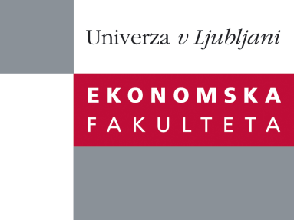

Raziskovalni center Ekonomske fakultete
organizira znanstveno - raziskovalni seminar,
ki bo v sredo, 21. septembra 2011, ob 15:00 uri
v Sejni sobi CISEF-a na Ekonomski fakulteti v Ljubljani.

Dr. Jodie Moll

(Manchester Business School, University of Manchester)

bo predstavila članek:

“Designing mediating instruments: capital budgeting and the coordination of research and development”

Research on capital budgeting has typically confined itself to the valuation of investments. This has resulted in the neglect of the actual practices for managing long-term interdependent processes of capital spending that often extend beyond the boundaries of firms. This research aims to redress that oversight.

O predavateljici: Jodie joined the University of Manchester in September 2003, having previously held a lecturing position at Griffith University (Australia). Her academic background is in Management Accounting, Financial Accounting and Public Sector Financial Management. Research Interests: Management Control Systems; Organisational Change; Management Accounting; Public Sector Accounting; Public Sector Reform; Institutional Theory; Garbage Can Model.

Na brezplačni seminar se lahko prijavite v pisarni RCEF, po telefonu (01) 58-92-490, ali po e-pošti na naslov sodelavec.rcef@ef.uni-lj.si do torka, 20.09.2011.
Vljudno vabljeni!

