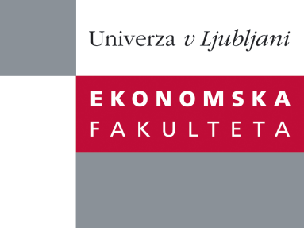

Raziskovalni center Ekonomske fakultete
organizira znanstveno - raziskovalni seminar,
ki bo v četrtek, 22. Marca 2012, ob 13:00 uri
v P-109 na Ekonomski fakulteti v Ljubljani.

Predstavljen bo članek:

˝The impact of a project organisational culture and team rewarding on project performance˝

avtor: viš. pred. dr. Aljaž Stare, Univerza v Ljubljani, Ekonomska fakulteta

˝In the opinion of many Slovenian project stakeholders and team members the maturity level of project management in the enterprises is quite low. Many related weaknesses have been exposed during project management training sessions, interviews and discussions with more than 2,000 team members in the last ten years. Despite the official internal rules governing how projects should be implemented, many stakeholders do not consider them. The consequences are a low level of authority enjoyed by project managers, a low level of support of line managers, and unsuitable project teams. Team members also complain that they do not receive any extra bonuses for perfectly executed projects. All of these factors could be subsumed within a project organisational culture, which forms part of a corporate culture. The goals of the research presented in the seminar were to identify the level of project organisational culture in Slovenian enterprises, which types of monetary rewards are available in enterprises, the impact of each type of reward and cultural factors on efficient project execution, and whether efficient project execution depends more on the organisational culture or on financial rewarding.˝

Na brezplačni seminar se lahko prijavite v Službi za znanstveno raziskovalno delo, po telefonu (01) 58-92-490, ali po e-pošti research.seminars@ef.uni-lj.si, in sicer do srede, 21.03.2012.

Vljudno vabljeni!

