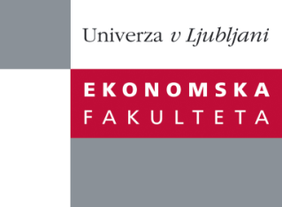

Raziskovalni center Ekonomske fakultete
organizira znanstveno - raziskovalni seminar,
ki bo v četrtek, 16. Maja 2013, ob 13:00 uri
v P-109 na Ekonomski fakulteti v Ljubljani.

Predstavljen bo članek:

“Accountant Transgressions and Empathy: A Mirror Neuron Investigation”

Avtorji: prof. dr. Frank Hartmann, Professor of Accounting and Management Control, RSM Erasmus University, Philip Eskenazi (doktorski študent), Wim Rietdijk (doktorski študent)

»Management accountants have a fiduciary duty to ensure integrity of corporate financial reporting, but are often faced with social pressure from local management to violate accounting principles this duty. This may have strong negative consequences for the organization, and therefore accountant transgressions are under serious scrutiny. In this paper, we use EEG evidence of a sample of accountants to predict their inclination to give in to social pressure. Specifically, we investigate whether more empathic accountants, as measured by mu suppression in the motor cortex in a dynamic emotional facial expressions task, are more likely to show such violations. Our analysis extends the mirror neuron literature, which argues that this system is the neural substrate for empathy. Our experimental task uses a set of validated vignettes that describe situations in which local managers put emotional pressure on accountants to carry out an action in violation of a professional or an ethical norm. Our initial analysis of results reveals a strong and significant positive correlation between mirror neuron activity and transgressive behavior. This suggests that empathy may be an important mediator of the relationship between social pressure and accountants’ violations of their fiduciary duty, which suggests that biological factors are relevant to understand problems of financial reporting reliability.«

Na brezplačni seminar se lahko prijavite v Službi za znanstveno raziskovalno delo, po telefonu (01) 58-92-490 ali po e-pošti research.seminars@ef.uni-lj.si, do srede, 15.05.2013.
Vljudno vabljeni!

