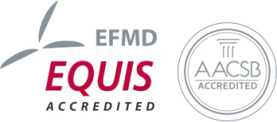
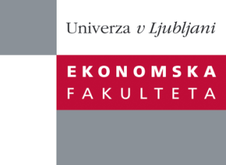

Raziskovalni center Ekonomske fakultete
organizira znanstveno - raziskovalni seminar,
ki bo v četrtek, 23. Maja 2013, ob 12:00 uri
v P-109 na Ekonomski fakulteti v Ljubljani.

Predstavljen bo članek:

“Bibliometric Methods in Management and Organization: A Review”

Avtor: Ivan Zupic, doktorski študent, Ekonomska fakulteta, Univerza v Ljubljani (izr. prof. dr. Tomaž Čater, Ekonomska fakulteta, Univerza v Ljubljani)

˝ We aim to develop a meaningful single source reference for (management) scholars interested in bibliometric methods. Bibliometric methods introduce a measure of objectivity into evaluation of scientific literature and have the potential to increase rigor and mitigate researcher bias in reviews of scientific literature. We reviewed 86 studies that used bibliometric methods in management and organization science published between 1993 and 2012. We found that co-citation analysis is the most used method for exploration of knowledge base of scientific fields. Bibliographic coupling is neglected method for examining research fronts. Co-word and co-author analysis are used only sporadically. Social network analysis tools are gradually replacing multidimensional scaling for visualization of research fields. We describe some newer methods (tri-citation, latent semantic analysis, webometrics) which could become prominent in the future and present a workflow for conducting bibliometric studies.˝

Na brezplačni seminar se lahko prijavite v Službi za znanstveno raziskovalno delo, po telefonu (01) 58-92-490 ali po e-pošti research.seminars@ef.uni-lj.si, do sreda, 22.05.2013.
Vljudno vabljeni!

