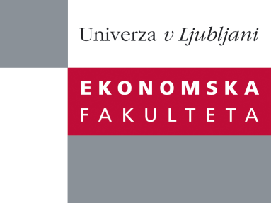

Raziskovalni center Ekonomske fakultete
organizira znanstveno - raziskovalni seminar,
ki bo v sredo, 09. Maja 2012 ob 12:00 uri
v RZ001 na Ekonomski fakulteti v Ljubljani.

Predstavljen bo članek:

"Rent Sharing, Wage Determination and Participation to International Trade˝

avtor: Luca Marcolin, Katholieke Universiteit Leuven, CES & VIVES

˝In this paper we explore the scope of international pro_t sharing for Slove-nian _rms. Our contribution is to extend the approach proposed for the US by Budd, Konings & Slaughter (2005) by allowing not only for di_erences between domestic and foreign owned _rms, but also between importers and exporters. We claim that _rms engaged in international trade enhance their performance through knowledge spillovers and technology upgrading simi- larly to what happens for companies which are part of multinational groups, and that this superior performance can translate into substantial wage pre-mia to workers. We exploit a unique dataset for Slovenian _rms for the period 1994-2002 resulted from the matching of _rm accounting, trade and ownership data. We further distinguish our analysis from most previous works by looking at both manufacturing and services companies, as well as by taking into account the geographical breakdown of Slovenian trade and origin of foreign ownership. The most complete empirical speci_cation controls for _rm, sectoral and time invariant characteristics, as well as for the endogeneity of pro_tability, which derives from the possibility of hiring higher quality workers if the _rm is more pro_table. Preliminary results suggest that pro_ts do have an impact on wages de pending on ownership and trade status, both for services and manufacturing _rms. The magnitude and sign of the estimated wage elasticities are in line with previous studies where comparisons are possible, so that domestic and non-exporting _rms are found to o_er minor wage premia to their workers.˝

Na brezplačni seminar se lahko prijavite v Službi za znanstveno raziskovalno delo, po telefonu (01) 58-92-490, ali po e-pošti research.seminars@ef.uni-lj.si, do 08.05.2012.
Vljudno vabljeni!

