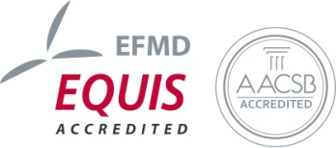
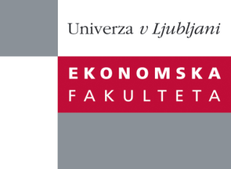

Raziskovalni center Ekonomske fakultete
organizira znanstveno - raziskovalni seminar,
ki bo v četrtek, 04. Aprila 2013, ob 12:00 uri
v P-109 na Ekonomski fakulteti v Ljubljani.

Predstavljen bo članek:

“The Quality of Bank Capital and Bank Lending Behavior in the Global Financial Crisis"

Avtor: prof. dr. Marko Košak, EF (skupaj z: doc. dr. Igor Lončarski, doc. dr. Matej Marinč, Ekonomska fakulteta, Univerza v Ljubljani; prof. dr. Shaofang Lia, Amsterdam Center for Law & Economics (ACLE), Faculty of Economics and Business, University of Amsterdam)

In this paper we analyze whether bank funding structure affects bank lending behavior. In particular, we are interested in the relationship between the high quality (Tier 1) and lower quality (Tier 2) bank capital and lending growth during the Global financial crisis. We use annual financial data for banks worldwide in the period 2000-2010. Our findings suggest that Tier 1 capital ratio is positively associated with loan growth during the Global financial crisis. We find some evidence that Tier 2 capital and interbank deposits spur bank lending during normal times but not during the Global financial crisis. In contrast, customer deposits positively affect bank lending during the Global financial crisis. Interestingly, high Tier 1 ratios of competing banks spur bank lending in normal times but discourage bank lending during the Global financial crisis. We also find that the government ownership of banks an be associated with stronger lending during the Global financial crisis.

Na brezplačni seminar se lahko prijavite v Službi za znanstveno raziskovalno delo, po telefonu (01) 58-92-490 ali po e-pošti research.seminars@ef.uni-lj.si, do sreda, 03.04.2013.
Vljudno vabljeni!

