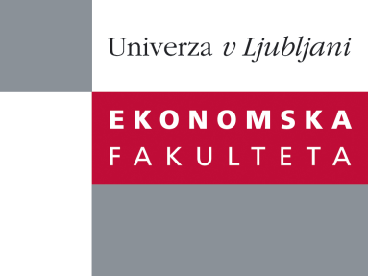

Raziskovalni center Ekonomske fakultete
organizira znanstveno - raziskovalni seminar,
ki bo v torek, 4. oktobra 2011, ob 17:00 uri
v P-201 na Ekonomski fakulteti v Ljubljani.

Prof. Wayne W. Yu

(School of Accounting and Finance,The Hong Kong Polytechnic University)

bo predstavil članek:

“An analysis of the use of derivatives by the Canadian mutual fund industry”

In this paper we examine the use of derivatives by mutual funds in Canada. First, both the incidence and extent of derivatives usage are low. Second, larger, growth-oriented, domestic equity funds are more likely to use derivatives. We then compare returns and risks between derivative users and non-users with the following findings: (1) There exist no differences between users and non-users for foreign equity funds; (2) For fixed-income funds, users have higher returns and risks than non-users; (3) For domestic equity funds, users have lower returns but higher risks than non-users; however, the differentials disappear if warrants are excluded from the definition of derivatives.

Na brezplačni seminar se lahko prijavite v pisarni RCEF, po telefonu (01) 58-92-490, ali po e-pošti na naslov sodelavec.rcef@ef.uni-lj.si do ponedeljka, 03.10.2011.
Vljudno vabljeni!

