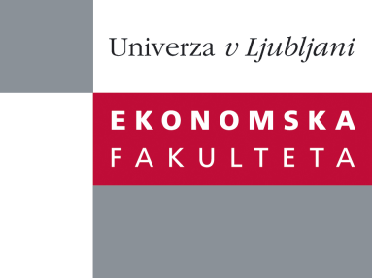

Raziskovalni center Ekonomske fakultete
organizira znanstveno - raziskovalni seminar,
ki bo v sredo, 23. Maja 2012 ob 12:00 uri
v P-109 na Ekonomski fakulteti v Ljubljani.

Predstavljen bo članek:

˝Analytical cyclical price-dividend ratios ˝

avtor: Alessandro Sbuelz, Catholic University, Milano (soavtor: Fausto Mignanego, Catholic University, Milano)

˝How non-linear are (log) price-dividend ratios in the fundamental state variables? The accuracy of log-linear approximations lies at the heart of much contemporary asset pricing. We analytically solve a parsimonious partial-equilibrium valuation model and uncover preliminary evidence suggesting that some caution be in order only if the fundamentals are extremely persistent. We work out the stock price's exact exposure to discount rate risk to shed more light on the "good" nature of discount rate risk relative to cash flow risk. Persistence in the price of risk not only inflates such exposure but also renders it markedly dependent on the level of the price of risk.˝

Na brezplačni seminar se lahko prijavite v Službi za znanstveno raziskovalno delo, po telefonu (01) 58-92-490, ali po e-pošti research.seminars@ef.uni-lj.si, do 22.05.2012.

Vljudno vabljeni!

