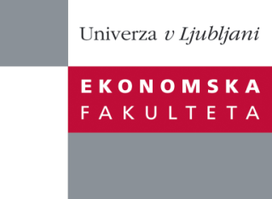

Raziskovalni center Ekonomske fakultete
organizira znanstveno - raziskovalni seminar,
ki bo v torek, 28. Maja 2013, ob 13:00 uri
v P-019 na Ekonomski fakulteti v Ljubljani.

Predstavljen bo članek:

“Publishing research - journal selection and paper write-up”

Avtor: red. prof. dr. Aviv Shoham, University of Haifa, Israel

˝ The main topic of the research seminar given by prof. Aviv Shoham is the challenges and suggestions for publishing scientific research in the international scientific journals. The presentation is going to focus on the journal selection and paper write-up. Within the topic of the journal selection issues like citations and submission process will be raised. When discussing the paper write-up, the presentation will unfold the major issues the authors are struggling with at the different stages of writing as well as at the different parts of their paper structure. Prof. Aviv Shoham is going to build the discussion on his personal experiences as the author and as the reviewer/member of the editorial board of several scientific journals.˝

SHORT BIO OF THE AUTHOR: Aviv Shoham (PhD, 1993, University of Oregon) is an associate professor of marketing and Head of the Business Administration Department at University of Haifa, Israel. He serves as a visiting professor at the Ljubljana University, Slovenia. His research focuses on international marketing management/strategy and international consumer behavior. His research has been published in journals such as the Journal of the Academy of Marketing Science, Management International Review, the Journal of International Marketing, International Marketing Review, the Journal of Business Research, the Journal of Advertising Research, International Business Review, the Journal of Applied Social Psychology, the European Journal of Marketing, European Journal of Management, Journal of Engineering and Technology Management, and the Journal of Global Marketing.

Na brezplačni seminar se lahko prijavite v Službi za znanstveno raziskovalno delo, po telefonu (01) 58-92-490 ali po e-pošti research.seminars@ef.uni-lj.si, do ponedeljka, 27.05.2013.

Vljudno vabljeni!

