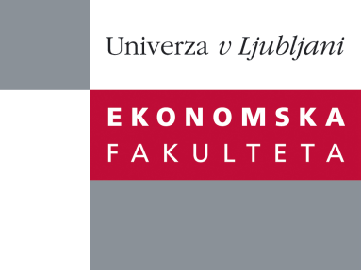

Raziskovalni center Ekonomske fakultete
organizira znanstveno - raziskovalni seminar,
ki bo v četrtek, 19. Aprila 2012, ob 12:00 uri
v P-109 na Ekonomski fakulteti v Ljubljani.

Predstavljen bo članek:

˝The Herd Behaviour Index: A new measure for the implied degree of co-movement in stock markets˝

avtor: prof.dr. Jan Dhaene, Katholieke Universiteit Leuven - Department of Applied Economics (skupaj z Daniel Linders, Wim Schoutens in David Vyncke)

˝We introduce a new and easy-to-calculate measure for the expected degree of herd behavior or co-movement between stock prices. This forward looking measure is model-independent and based on observed option data. It is baptized the Herd Behavior Index (HIX). The degree of co-movement in a stock market can be determined by comparing the observed market situation with the extreme (theoretical) situation under which the whole system is driven by a single factor. The HIX is then determined as the ratio of an option-based estimate of the risk-neutral variance of the market index and an option-based estimate of the corresponding variance in case of the extreme single factor market situation.˝

Na brezplačni seminar se lahko prijavite v Službi za znanstveno raziskovalno delo, po telefonu (01) 58-92-490, ali po e-pošti research.seminars@ef.uni-lj.si, in sicer do srede, 18.04.2012.

Vljudno vabljeni!

