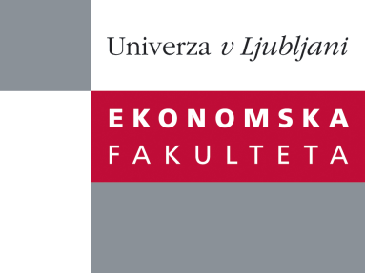

Raziskovalni center Ekonomske fakultete
organizira znanstveno - raziskovalni seminar,
ki bo v torek, 4. oktobra 2011, ob 16:00 uri
v P-201 na Ekonomski fakulteti v Ljubljani.

Prof. Piyush Sharma

(Department of Management and Marketing, The Hong Kong Polytechnic University)

bo predstavil članek:

“Deliberate Self-Indulgence versus Involuntary Loss of Self-Control: Toward a Robust Cross-Cultural Consumer Impulsiveness Scale”

There is neither a consensus about the dimensionality of the consumer impulsiveness construct nor sufficient evidence about the validity and cross-cultural measurement equivalence of its various scales. We address these gaps by using cross-cultural differences in control orientations as the conceptual foundation for a more robust consumer impulsiveness scale. Specifically, we demonstrate that unlike individualistic consumers, collectivistic consumers distinguish between deliberate self-indulgence and involuntary loss of self-control, as reflected in the three-factor structure (prudence, self-indulgence, and self-control) for the collectivists and a two-factor structure (prudence and hedonism) for the individualists. We also discuss some implications and limitations of this research.
Na brezplačni seminar se lahko prijavite v pisarni RCEF, po telefonu (01) 58-92-490, ali po e-pošti na naslov sodelavec.rcef@ef.uni-lj.si do ponedeljka, 03.10.2011.
Vljudno vabljeni!

