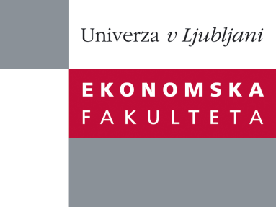

Raziskovalni center Ekonomske fakultete
organizira znanstveno - raziskovalni seminar,
ki bo v sredo, 30. Maja 2012 ob 12:00 uri
v P-109 na Ekonomski fakulteti v Ljubljani.

Predstavljen bo članek:

˝Modeling hourly prices of electricity for pricing out of the money options˝

avtorji: Gregor Cigüt in izr. prof. dr. Aleš Ahčan, Univerza v Ljubljani, Ekonomska fakulteta

˝ In this article we perform the time series analysis of hourly prices of electricity quoted at EEX in order to price out of the money options. We model the prices through the generalized Ornstein-Uhlenbeck process with seasonally adjusted ARCH process for volatility. Afterwards we model the residuals and price out of the money (call) options via the Esscher transform in order to value a certain trading strategy backed by alternative electricity supply. We examine the effect which the assumed distribution of residuals has on the net present value of such trading strategy.˝

Na brezplačni seminar se lahko prijavite v Službi za znanstveno raziskovalno delo, po telefonu (01) 58-92-490, ali po e-pošti research.seminars@ef.uni-lj.si, do torka 29.05.2012.

Vljudno vabljeni!

