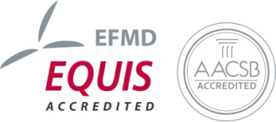
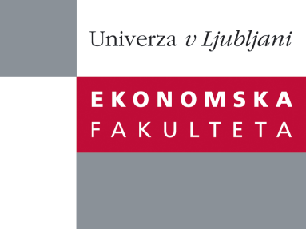

Raziskovalni center Ekonomske fakultete
organizira znanstveno - raziskovalni seminar,
ki bo v sredo, 16. Maja 2012, ob 12:00 uri
v P-109 na Ekonomski fakulteti v Ljubljani.

Predstavljen bo članek:

˝Employees' foreign language ability and commitment to organizational change: Implications based on employee perceptions˝

avtor: prof. dr. Sachiko Yamao, International Business at Department of Management and Marketing, University of Melbourne, Australia

˝We investigate Japanese employees’ self-perceived English language ability and their awareness of global human resource management practices at work as factors that predict their commitment to globalization of their organizations’ business operations. We see globalization of business operations, or increased level of personnel, informational, financial, and physical interactions and exchanges across national and cultural boundaries, as a change that imposes various challenges to Japanese employees. One such challenge is increase in the use of foreign language, and typically English language, at work. Based on the survey data gathered from employees of organizations based in Japan, we have found that Japanese employees’ self-perceived English language ability mediates the association between their awareness of global human resource management and their commitment to globalization of organizational operations. We have also found that Japanese employees’ attitude to work (i.e. work centrality) strengthens the association between their self-perceived English language ability and their commitment to globalization. We suggest that organizations globalizing their operations beyond Japan should be attentive to their employees’ English language ability and their awareness of global human resource management practices in gaining employees’ commitment to the organization’s global goal. Further, we suggest that to what extent an employee perceives his/her work important in his/her life plays a significant role in their commitment to organizational change.˝

Na brezplačni seminar se lahko prijavite v Službi za znanstveno raziskovalno delo, po telefonu (01) 58-92-490, ali po e-pošti research.seminars@ef.uni-lj.si, in sicer do torka, 15.05.2012.
Vljudno vabljeni!

