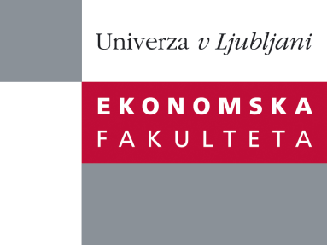

Raziskovalni center Ekonomske fakultete
organizira znanstveno - raziskovalni seminar,
ki bo v sredo, 5. oktobra 2011, ob 16:00 uri
v P-201 na Ekonomski fakulteti v Ljubljani.

Dr. Tom Hsiang in Girish Gujar

(Department of Logistics and Maritime Studies, The Hong Kong Polytechnic University)

bosta predavala na temo:

“Future of Quality - A Proposal for Research”

This talk will start from a historical review on the evolution of quality or quality management till now. Historically, this analysis will divide the evolution of quality into three periods. An arresting question is what will the future be for quality? The speakers will discuss their observations and propose that the fourth period of quality will involve intimately with the improvement and innovation of business models. A preliminary summary will be drawn. A wide open arena of future research about the future on quality will be discussed.

In today’s flat globalized world the levels of complicity and integration are inconceivable. Technology is pushing the event horizon beyond the understanding of human brains. In such circumstances all we can be sure of is the certainty of currently unperceivable events and processes and the extreme impact it will have on the business environment. As an example it is sufficient to state whether Google, Facebook and Apple could have been dreamt of a decade back. On the same note who can predict the next generation business successes. Our preliminary conclusions suggest that intangible factors such as trust, customer service and management culture in addition to innovativeness and transparency will be far more valuable than physical assets like plant and machinery or financial capital.
Na brezplačni seminar se lahko prijavite v pisarni RCEF, po telefonu (01) 58-92-490, ali po e-pošti na naslov sodelavec.rcef@ef.uni-lj.si do torka, 04.10.2011.
Vljudno vabljeni!

