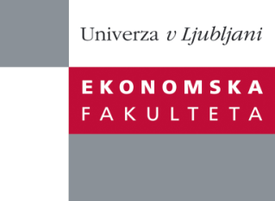

Raziskovalni center Ekonomske fakultete
organizira znanstveno - raziskovalni seminar,
ki bo v četrtek, 06. Junija 2013, ob 12:00 uri
v P-109 na Ekonomski fakulteti v Ljubljani.

Predstavljen bo članek:

“Displayed Passion and Angel Investing: Interactions Among Enthusiasm, Preparedness and Commitment”

Avtorica: prof. dr. Melisse S. Cardon, Lubin School of Business, Pace University, New York

˝ Entrepreneurial passion manifests in several different ways including affective display (enthusiasm), cognitive display (preparedness), and behavioral display (commitment) of the entrepreneur. We address mixed findings in the literature concerning which of these influence angel investor interest by 1) incorporating all three types of displayed passion in our model, and 2) examining not only independent effects but also potential interactions between affective, cognitive, and behavioral displays of passion. We test our hypotheses with decisions made by angel investors about live investment deals. Our findings suggest a relationship between preparedness and evaluations of funding potential, particularly when entrepreneurs have invested more of their own funds in the venture (a form of behavioral commitment). While we did not find a direct relationship between enthusiasm and evaluations of funding potential, our results suggest that there is a positive interactive effect of enthusiasm and efficient use of money and a negative interaction effect of enthusiasm and personal money invested, as well as enthusiasm and years pursuing the venture, on angel investor interest.˝

Na brezplačni seminar se lahko prijavite v Službi za znanstveno raziskovalno delo, po telefonu (01) 58-92-490 ali po e-pošti research.seminars@ef.uni-lj.si, do srede, 05.06.2013.

Vljudno vabljeni!

