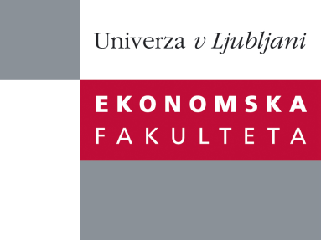

Raziskovalni center Ekonomske fakultete
organizira znanstveno - raziskovalni seminar,
ki bo v sredo, 06. Junija 2012 ob 12:00 uri
v P-109 na Ekonomski fakulteti v Ljubljani.

Predstavljen bo članek:

˝The Board of Directors in Hedge Fund Governance˝

avtor: dr. Peter G. Szilagyi (Cambridge Judge Business School, University of Cambridge)

˝Hedge fund boards have historically been overlooked as an institution lacking relevance and substance. Directors are indeed appointed by the fund manager, mostly supplied by service providers and director services, and often lacking in skills and incentives to monitor the fund. Nonetheless, they face growing pressure post-crisis from both investors and regulators to fulfill their fiduciary duties. This paper investigates the role and effectiveness of hedge fund boards for the first time, using hand-collected data from hedge fund documentation previously unavailable for academic research. We find several important results, including evidence that (i) board independence leads to improved fund performance, (ii) directors with risk management experience reduce fund risk without affecting returns, and (iii) funds deliver superior returns and lower risk when they give voting rights to investors (including to elect directors). We conclude that the board can be a very useful source of control in hedge funds, whose traditional governance model fundamentally focuses on the realignment of managerial interests.˝

Na brezplačni seminar se lahko prijavite v Službi za znanstveno raziskovalno delo, po telefonu (01) 58-92-490, ali po e-pošti research.seminars@ef.uni-lj.si, do torka 05.06.2012.

Vljudno vabljeni!

