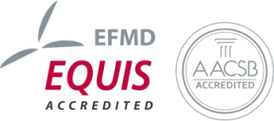
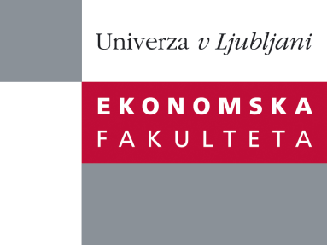

Raziskovalni center Ekonomske fakultete
organizira znanstveno - raziskovalni seminar,
ki bo v četrtek, 24. Maja 2012, ob 12:00 uri
v P-109 na Ekonomski fakulteti v Ljubljani.

Predstavljen bo članek:

“Activity Based Costing Approach in the measurement of Cost of Quality in SMEs: Case Study”

avtor: Dr. Yasemin ZENGIN KARAIBRAHIMOĞLU,
Accounting at Department of Business Administration,
Izmir University of Economics, Turkey

˝Since the 1950s, a considerable amount of attention has been given on the cost of quality (CoQ) in theory and in practice. Overall, it is argued that a precise measurement of the cost of quality requires a well established accounting system that provides accurate cost information. However, in the literature, it is generally considered that traditional cost accounting methods do not provide accurate cost data for the measurement of quality costs. Therefore, the aim of this study is to explore the role of activity-based costing (ABC) in supporting the measurement of CoQ in small and medium-sized enterprises (SMEs) in order to discuss the results of implementation, its benefits and drawbacks. Overall it was found that the use of ABC in the CoQ measurement provides the organization with the means to determine both value-added and non-value added quality-related activities and to detect improvement opportunities in the production process.˝

Na brezplačni seminar se lahko prijavite v Službi za znanstveno raziskovalno delo, po telefonu (01) 58-92-490, ali po e-pošti research.seminars@ef.uni-lj.si, in sicer do srede, 23.05.2012.

Vljudno vabljeni!

