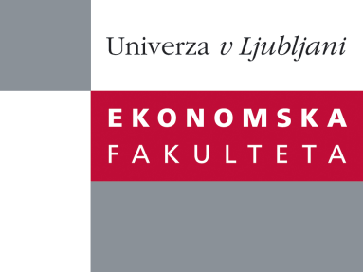

Research Office, Faculty of Economics
is organizing a scientific research seminar
on Tuesday, 22nd November 2011, at 15:00 pm
in the room P-111 at the Faculty of Economics, Ljubljana

Prof. Oded Stark

Distinguished Fellow, University of Bonn
University Professor, University of Klagenfurt
Adjunct Professor, University of Tuebingen
Honorary University Professor, University of Vienna
Distinguished Professor, Warsaw University
Distinguished Professor, Warsaw School of Economics
Presidential Professor of Economic Sciences (Poland)

will deliver a lecture:

“Integration, social distress and policy formation”

Abstract
I study the integration of regions and nations and as a merger of populations, which I interpret as a revision of social space and the comparison set; I illustrate the repercussion of a merger for aggregate social distress; and I consider policy responses. Specifically, I view the merger of populations as a merger of income vectors; I measure social distress by aggregate relative deprivation; I demonstrate that a merger strictly increases aggregate relative deprivation; and I show that a social planner is able to reverse this increase by means of least-cost, post-merger increases in individual incomes, but is unable to counter the increase by relying exclusively on a self-contained income redistribution that retains individual levels of wellbeing at their pre-merger magnitudes.

You can register for the free seminar by phone (01) 58-92-490, or by e-mail to research.seminars@ef.uni-lj.si until Monday, 21.11.2011.

Welcome!

