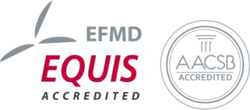
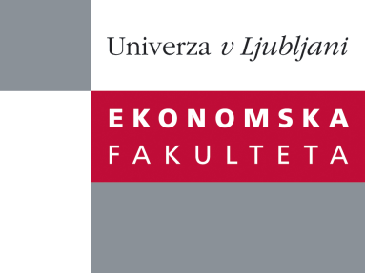

Raziskovalni center Ekonomske fakultete
organizira znanstveno - raziskovalni seminar,
ki bo v četrtek, 20. junija 2013, ob 12:00 uri
v P-109 na Ekonomski fakulteti v Ljubljani

Predstavljen bo članek:

“Staff Turnover Costs: In Search of Accountability”

Avtorji: Chris GUILDING, Dawne LAMMINMAKI, Lisa McMANUS
vsi iz Griffith University, Australia
»The nature of staff turnover accounting procedures in a labor intensive context has been examined by conducting interviews with human resource personnel in fourteen hotel properties and two theme parks. It was found that the main staff turnover accountability instruments involve monthly departmental reporting of staff turnover percentage levels and also the conduct of exit interviews. A degree of staff turnover costing was noted, although this practice was not extensively applied. Most interviewees supported the notion of allocating staff turnover costs to those operating departments experiencing the turnover. A muted form of this practice was observed in one hotel, however most interviewees had never contemplated or heard of the practice. Agency theory has been utilized as a framework for structuring a range of observed and potential staff turnover accountability relationships.«
Na brezplačni seminar se lahko prijavite v Službi za znanstveno raziskovalno delo, po telefonu (01) 58-92-490 ali po e-pošti research.seminars@ef.uni-lj.si, do srede, 19.6.2013.

Vljudno vabljeni!

