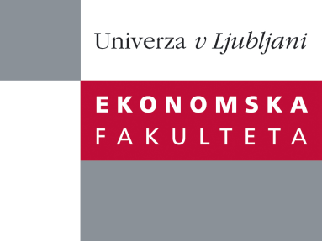

Raziskovalni center Ekonomske fakultete
organizira znanstveno - raziskovalni seminar,
ki bo v sredo, 23. Maja 2012, ob 14:00 uri
v P-109 na Ekonomski fakulteti v Ljubljani.

Predstavljen bo članek:

“Research networks (Cranet, CEEIRT) in IHRM - from an CEE (Central Eastern European) member perspective”

avtor: izr. prof. dr. Habil. Zsuzsa Karoliny, University of Pécs, Hungary

˝There is a deficit in empirical HRM (Human Resource Management) literature when it comes to identifying new patterns of Multinational Company (hereafter MNC) involvement in the region and the impact of these ongoing MNC operations on the patterns of HR/HRM activities of these firms. In this ongoing regional research project we examine the HR functions and practical applications of MNC subsidiaries in Central and Eastern Europe. The current research is part of long-term research cooperation – undertaken by the Central and Eastern European International Research Team – that is composed of researchers from universities across the Central and Eastern European (CEE) region and aimed at examining the changing HR practices and roles in MNC subsidiaries. Some of 279 foreign owned, legally independent subsidiaries participated in the questionnaire survey from seven countries (Croatia, Estonia, Hungary, Poland, Romania, Serbia and Slovakia). Respondents to this extensive regional sample of HR executives and managers were asked to describe the trends that have emerged in their HR activities and delivery systems and emergent roles for HRM professionals in this region in response to global and regional the socio-economic changes as MNCs redeploy their primary business activities and supporting HRM activities and infrastructure. In this contribution we summarize the relevant findings in connection with the most important topics of the survey.˝

Na brezplačni seminar se lahko prijavite v Službi za znanstveno raziskovalno delo, po telefonu (01) 58-92-490, ali po e-pošti research.seminars@ef.uni-lj.si, in sicer do torka, 22.05.2012.
Vljudno vabljeni!

