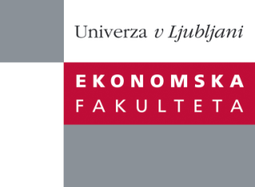

Raziskovalni center Ekonomske fakultete
organizira znanstveno - raziskovalni seminar,
ki bo v četrtek, 13. Junija 2013, ob 12:00 uri
v P-109 na Ekonomski fakulteti v Ljubljani.

Predstavljen bo članek:

“Evaluating probability of default: intelligent agents in managing a multi-model system”

Avtor: prof. dr. Miro Gradišar, Ekonomska fakulteta, Univerza v Ljubljani (soavtorji: Igor Perko in Samo Bobek Ekonomsko- poslovna fakulteta, Univerza v Mariboru)
˝ For the successful probability of default (PD) evaluation with the application of multiple prediction models two issues should be addressed: the accuracy of the analytic models which decreases over time and the evaluation of results which must be presented in a uniform shape. To deal with these two issues, a multi-agent system (MAS) and knowledge management systems (KMS) based process management system is proposed. The proposed system has two goals: to prevent the PD information quality deterioration by active management of analytical processes and to provide a universal access point allowing the simultaneous use of multiple prediction models.˝

Na brezplačni seminar se lahko prijavite v Službi za znanstveno raziskovalno delo, po telefonu (01) 58-92-490 ali po e-pošti research.seminars@ef.uni-lj.si, do srede, 12.06.2013.

Vljudno vabljeni!

