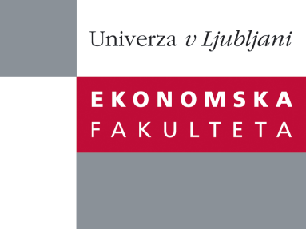

Raziskovalni center Ekonomske fakultete
organizira znanstveno - raziskovalni seminar,
ki bo v sredo, 16. Aprila 2014, ob 12:00 uri
v P-109 na Ekonomski fakulteti v Ljubljani.

Predstavljen bo članek:

“Market segmentation – useful insight or just a random grouping of consumers?”

avtor: Prof. dr. Sara Dolničar, Univerza v Queensland, Avstralija

˝A report on a research program on market segmentation and market segmentation methodology which started with Dolnicar’s PhD where she investigated whether neural networks are a suitable method for segmentation until more recent simulation studies determining sample size requirements for market segmentation studies.˝

Na brezplačni seminar se lahko prijavite v Službi za znanstveno raziskovalno delo, po telefonu (01) 58-92-490, ali po e-pošti research.seminars@ef.uni-lj.si, in sicer do torka, 15.4.2014.

Vljudno vabljeni!

